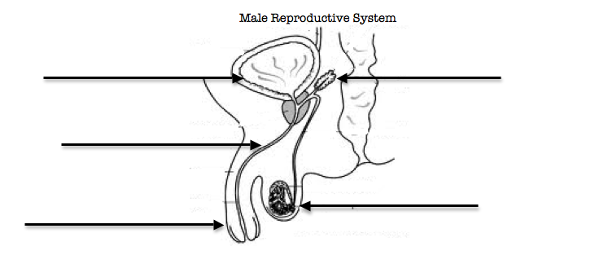
Human Body, Animal/Plant Reproduction Review Packet (20pts)
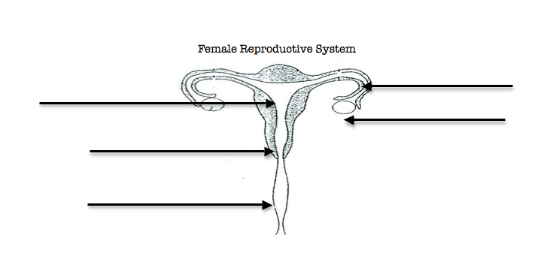

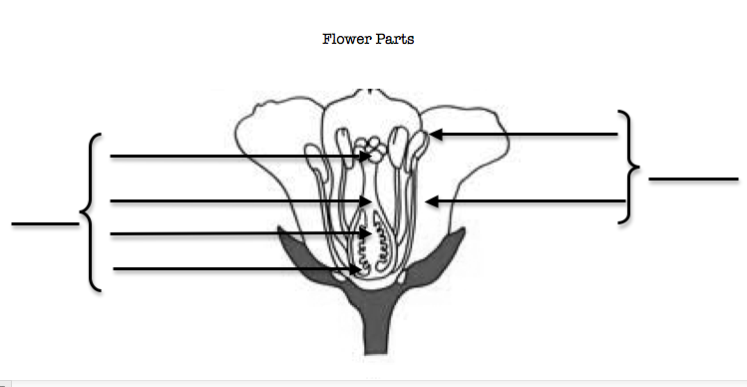
1. Compare and contrast the human reproductive system to flower pollination.
________________________________________________________________________________________________________________________________________________________________________________________________________________________________________________________________________________________________________________________________________________
________________________________________________________________________________________________________________________________________________________________________
2. What is Asexual reproduction. What are the advantages and disadvantages of this method of reproduction.
________________________________________________________________________________________________________________________________________________________________________________________________________________________________________________________________________________________________________________________________________________
________________________________________________________________________________________________________________________________________________________________________3. What is sexual reproduction. What are the advantages and disadvantages of this mode of reproduction.
________________________________________________________________________________________________________________________________________________________________________________________________________________________________________________________________________________________________________________________________________________
________________________________________________________________________________________________________________________________________________________________________
4. Draw the path that pollen has to take in order to fertilize the ovule and create a fruit/seed.

Pollen is collected from the anther by a pollinator | Pollen is placed on the stigma of another flower | Pollen travels in a pollen tube down the style | Pollen reaches the ovules in the ovary fertilizing them | The ovary becomes a fruit and the ovule becomes a seed.

5. Attach your invisible man sheet to this paper. Describe the 5 systems you learned about in a few sentences each.

