Pollinators and Pollination
Name: _________________
Period: __________
Do Now: Complete the “Know” and “Want to Know” section of your KWL chart about pollinators.
K
W
L

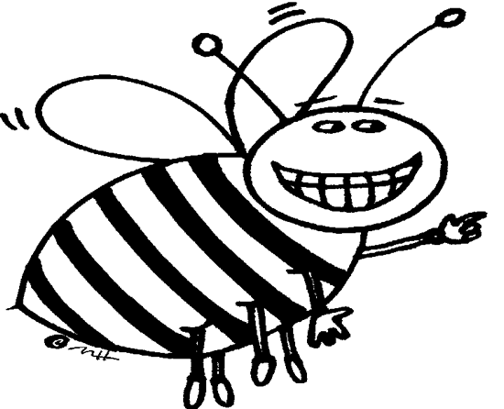

Read the article below. Use the text tags stapled to your packet to mark up the text.

BEES
Bees are active during the day, visiting flowers to obtain pollen and nectar for food. They use their senses of sight and smell to lead them to specific flowers, preferring sweet-smelling flowers and blossoms that are yellow, blue, purple, and white (red looks like black to them because they see in Ultraviolet). Venation patterns can be useful nectar guides, but it appears that the color contrast of a flower with its background has a greater influence on bee preference. To withdraw pollen, a bee lands on the flower grabbing the tube with its jaws and vibrates hundreds of times a second. This action causes the pollen grains to bounce up and down in the tube blasting out in a cloud that coats the bee. As it flies off, the bee gathers the grains on its fur and tucks most of them in wet clumps on its legs. It can later feed the clumps to larvae back at its hive.
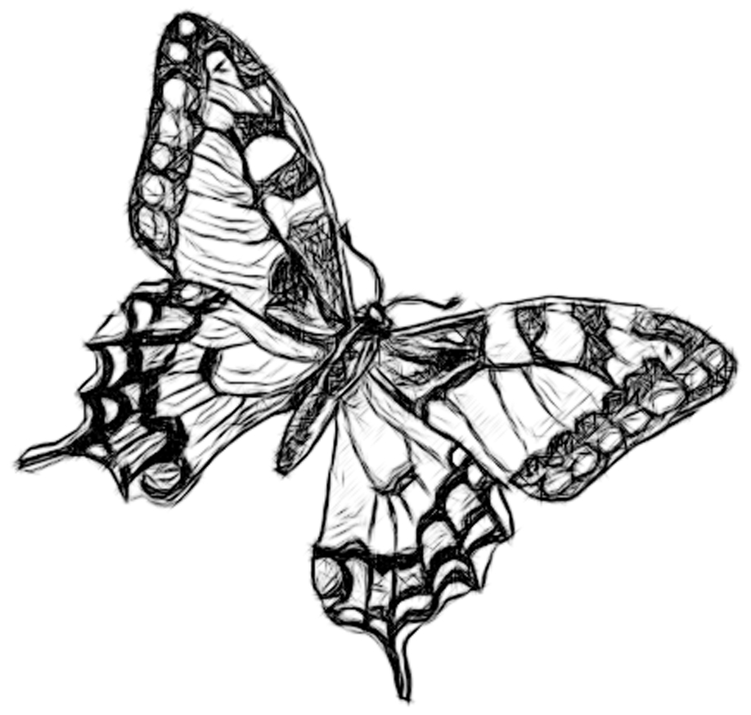
BUTTERFLIES
Butterflies are active during the day, visiting flowers to obtain nectar for food. Due to a poor sense of smell, butterflies rely mainly their sense of sight to lead them to flowers. They prefer clustered blossoms that are red, orange, yellow or blue. Butterflies are not strong enough to hover over a flower so they must land on a flower platform to feed. They have a long tongue called a proboscis they use as a straw to sip nectar out of deep narrow flower tubes. Butterflies are poor pollen collectors standing precariously on tall thin legs without any specialized structures for collection.

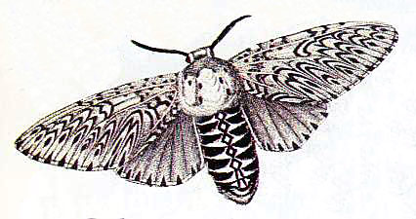
MOTHS
Most are commonly active during twilight or night, visiting flowers to obtain nectar for food. Nectar from flowers and sugar from sap or overripe fruit provide most of the nutrition that moths need. The have a long tongue like butterflies, also called a proboscis, to suck nectar out of flowers. They will also sip at mud puddles for mineral salts, and feed at animal scat, bird droppings, or animal carcasses to get amino acids and other nutrients. Moths use mainly their sense of smell, and some sight, to lead them to flowers. They are attracted to strong, sweet perfuming flowers that release their scent only at night. Moths prefer blossoms that are typically pale or white so they reflect moonlight. They usually hover above the flower to feed.

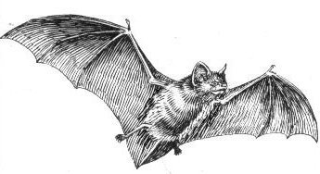
BATS
Bats are nocturnal and therefore only pollinate flowers that open at night lured by copious amounts of dilute nectar and insects. Bats use their very long tongue to slurp up the nectar. The bat’s tongue is so long that when the bat isn’t using it, his (her) tongue is rolled up in the body underneath the rib cage! Bats require large brush or bowl shaped flowers, as they must land in order to feed. Bats tend to like flowers that have a strong musty odor and are white green or purple in color. Due to their size and intelligence they are more reliable than other pollinators and can carry a large amount of pollen long distances.

BEETLES
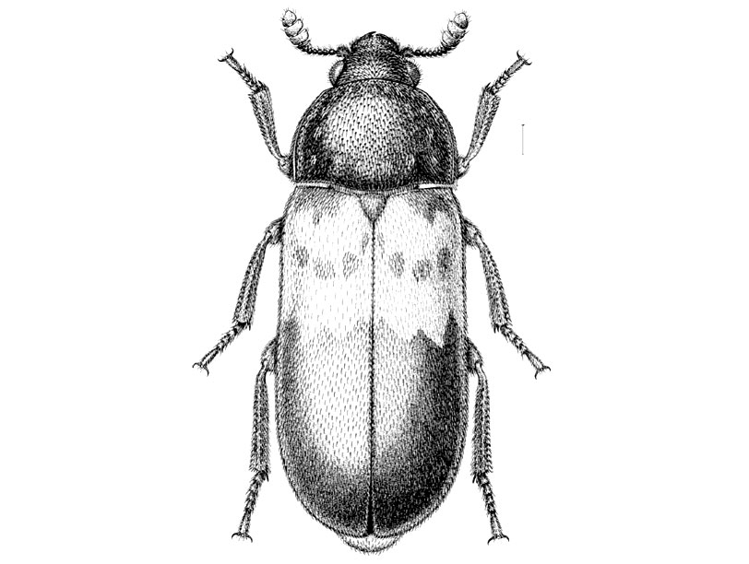
Beetles comprise the largest set of pollinating animals, due to their sheer numbers. They are responsible for pollinating 88% of the world’s flowers. Beetles will eat their way through petals and other floral parts, even defecating within the flower, presenting a cost to the plant. Research shows that beetles are capable of color vision. Beetles typically gravitate towards bowl shaped flowers with sexual organs exposed, white or green coloration often with a dark center or “eye”. Beetle pollinate flowers are moderate nectar producers, open during the day, and have spicy sweet or fermented smells.
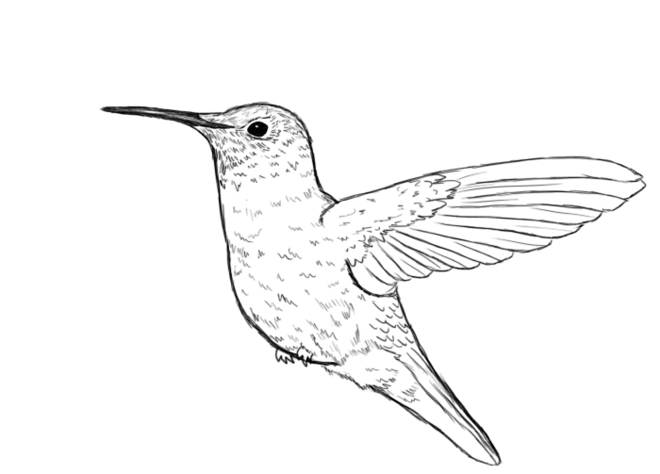
BIRDS
Hummingbirds have very good eyes and are extremely attracted to red. They thrust their long slender bills into flower tubes for abundant dilute nectar, withdrawing faces dusted in pollen. Birds are usually attracted to flowers that are tubular and have petals that are curved outward. Birds have a poor sense of smell; so odorless flowers are most common. Many need strong supports for perching while pollinating.

Interview your elbow pollinator using the questions below and sketch a flower that would be adapted to their specifications.

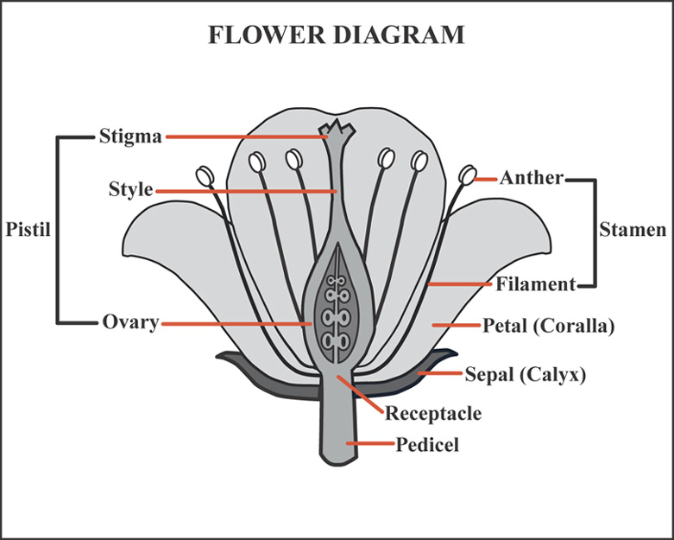
Flower Creation Interview Flower Design Quick Sketch

1. What color(s) are you attracted to?

2. What scent do you like?

3.

4.


Mind Map: Create your own mind map or brainstorm to organize details about your pollinator. Its needs, likes and dislikes. Use Specific evidence from the text on the previous page.

Flower Design Plan: Collaborate with a like pollinator partner to create a flower design that is adapted to the specific likes and needs of your pollinator. Make sure to include all flower structures present in a perfect flower.
Flower structure checklist
(cross off as you go)
- Petals
- Stigma
- Style
- Ovary
- Anther
- Filament
- Sepal
- Stamen
- Pistil

Now build it!

